**LAB 1: React-bootstrap**

By [traltb@fe.edu.vn](mailto:traltb@fe.edu.vn)

Dựa trên yêu cầu đã làm ở Exercise1, hãy bổ sung thêm 1 số tính năng sau:

1. Thiết kế sử dụng carousels: 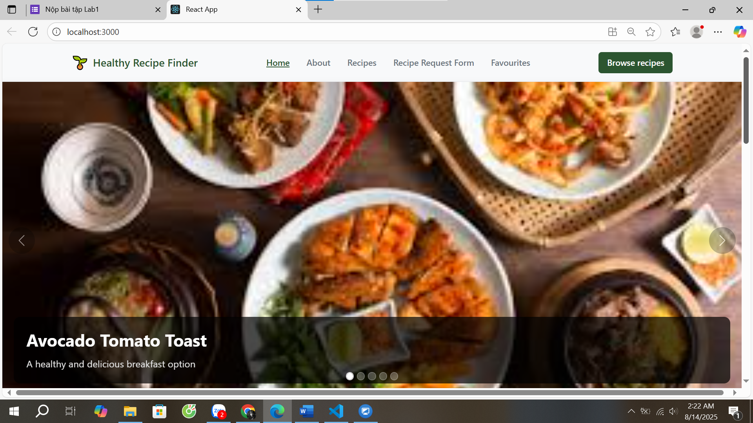
2. import 'bootstrap/dist/css/bootstrap.min.css';
3. import React from 'react';
4. import { Carousel } from 'react-bootstrap';
5. import './Carousel.css';
6. const CarouselComponent = () => {
7. const carouselItems = [
8. {
9. id: 1,
10. image: '/images/avocado-tomato-toast.jpg',
11. title: 'Avocado Tomato Toast',
12. description: 'A healthy and delicious breakfast option',
13. alt: 'Avocado tomato toast on bread'
14. },
15. {
16. id: 2,
17. image: '/images/banana-oat-pancakes.jpg',
18. title: 'Banana Oat Pancakes',
19. description: 'Nutritious pancakes perfect for any morning',
20. alt: 'Fluffy banana oat pancakes'
21. },
22. {
23. id: 3,
24. image: '/images/greek-yogurt-berry-parfait.jpg',
25. title: 'Greek Yogurt Berry Parfait',
26. description: 'Fresh berries with creamy Greek yogurt',
27. alt: 'Greek yogurt parfait with berries'
28. },
29. {
30. id: 4,
31. image: '/images/mediterranean-chickpea-salad.jpg',
32. title: 'Mediterranean Chickpea Salad',
33. description: 'Fresh and flavorful Mediterranean cuisine',
34. alt: 'Colorful Mediterranean chickpea salad'
35. },
36. {
37. id: 5,
38. image: '/images/one-pan-lemon-garlic-salmon.jpg',
39. title: 'Lemon Garlic Salmon',
40. description: 'Easy one-pan salmon with zesty flavors',
41. alt: 'Lemon garlic salmon fillet'
42. }
43. ];
44. const carouselStyles = {
45. carouselContainer: {
46. marginBottom: '2rem',
47. boxShadow: '0 4px 12px rgba(0,0,0,0.1)',
48. borderRadius: '0',
49. overflow: 'visible'
50. }
51. };
52. return (
53. <div className="carousel-wrapper" style={carouselStyles.carouselContainer}>
54. <Carousel
55. interval={4000}
56. pause="hover"
57. indicators={true}
58. controls={true}
59. fade={false}
60. slide={true}
61. >
62. {carouselItems.map((item) => (
63. <Carousel.Item key={item.id}>
64. <img
65. className="d-block w-100"
66. src={item.image}
67. alt={item.alt}
68. />
69. <Carousel.Caption>
70. <h3>{item.title}</h3>
71. <p>{item.description}</p>
72. </Carousel.Caption>
73. </Carousel.Item>
74. ))}
75. </Carousel>
76. </div>
77. );
78. };
79. export default CarouselComponent;
80. Thêm dropdown Sort by

* Cho phép chọn nhiều tiêu chí sắp xếp: Name A→Z, Z→A, Prep ↑/↓, Cook ↑/↓.
* Hiển thị danh sách các công thức món ăn theo tiêu chí.

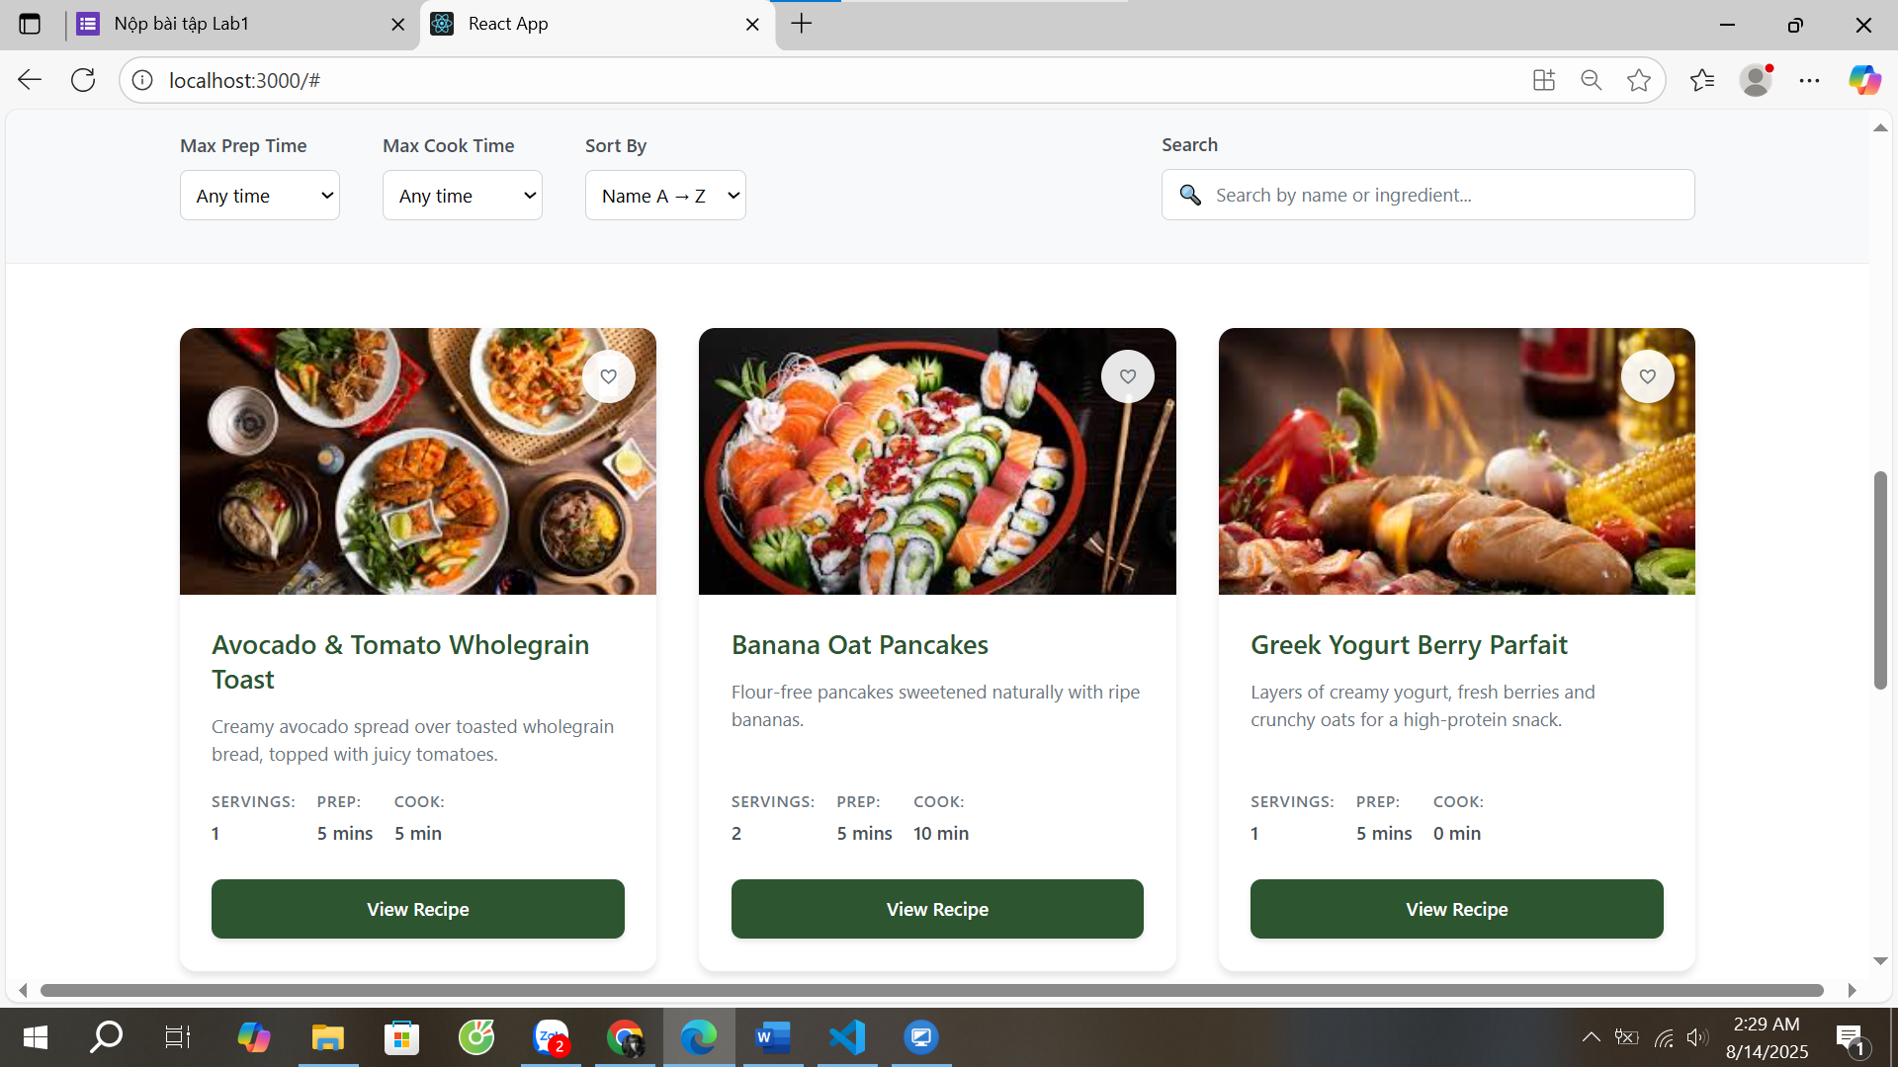

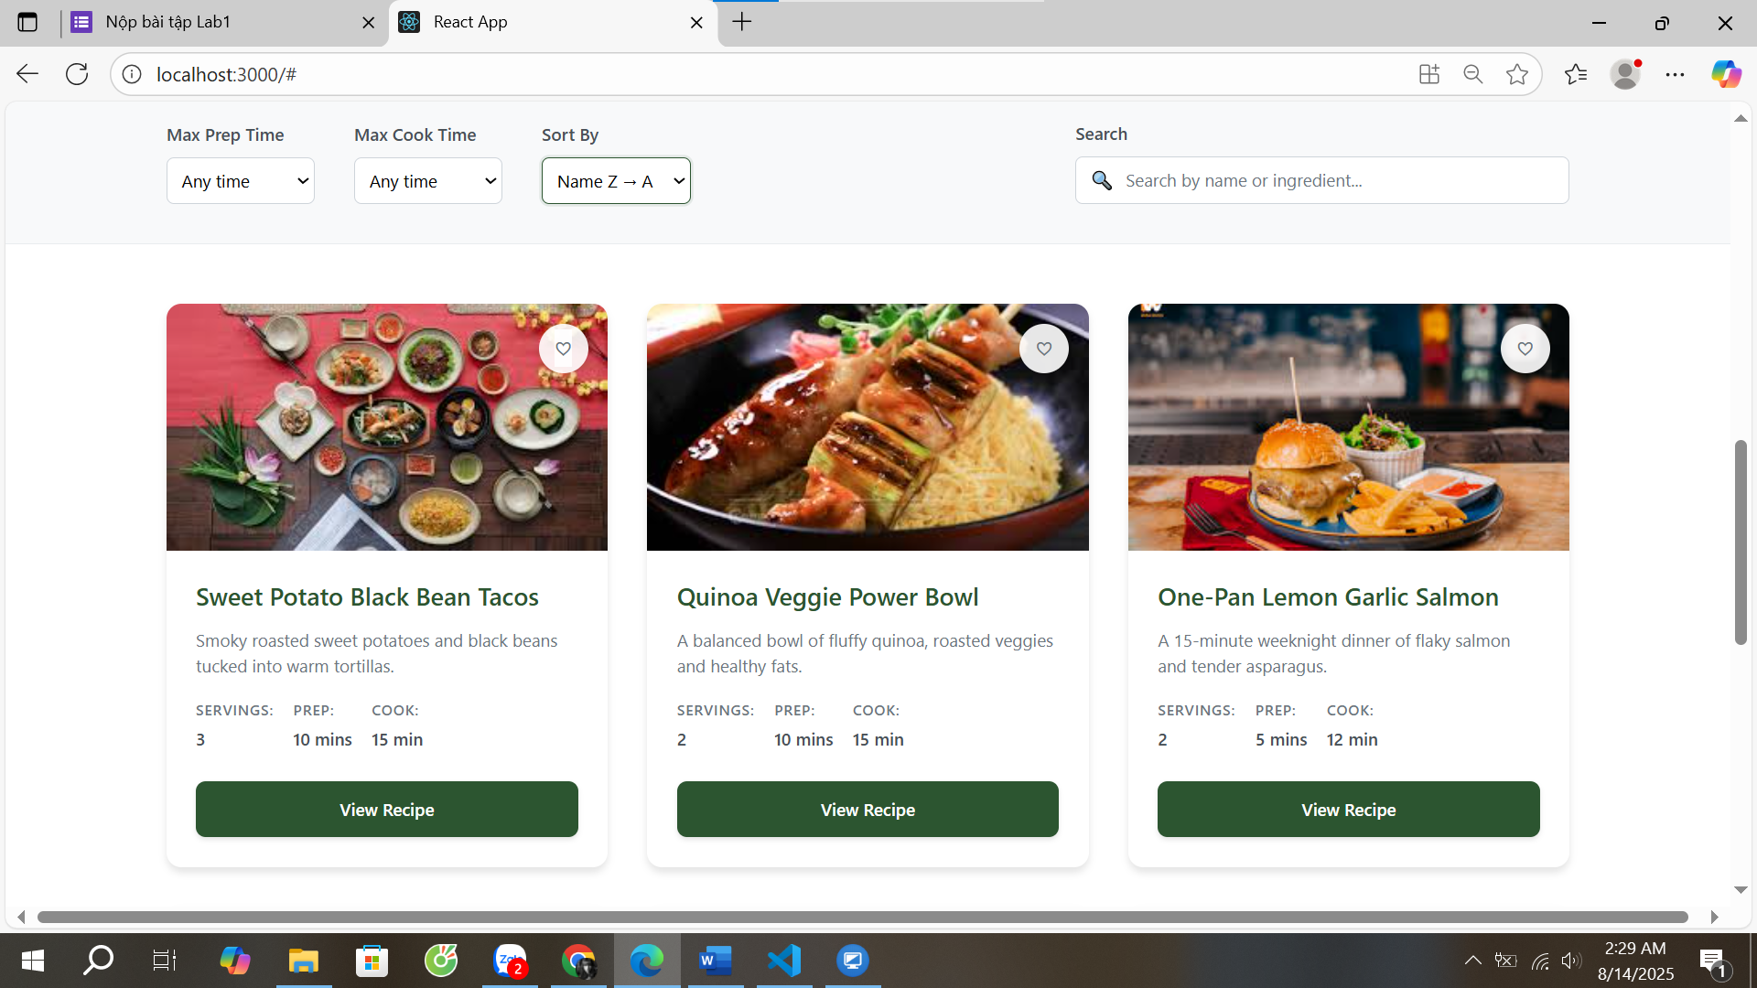

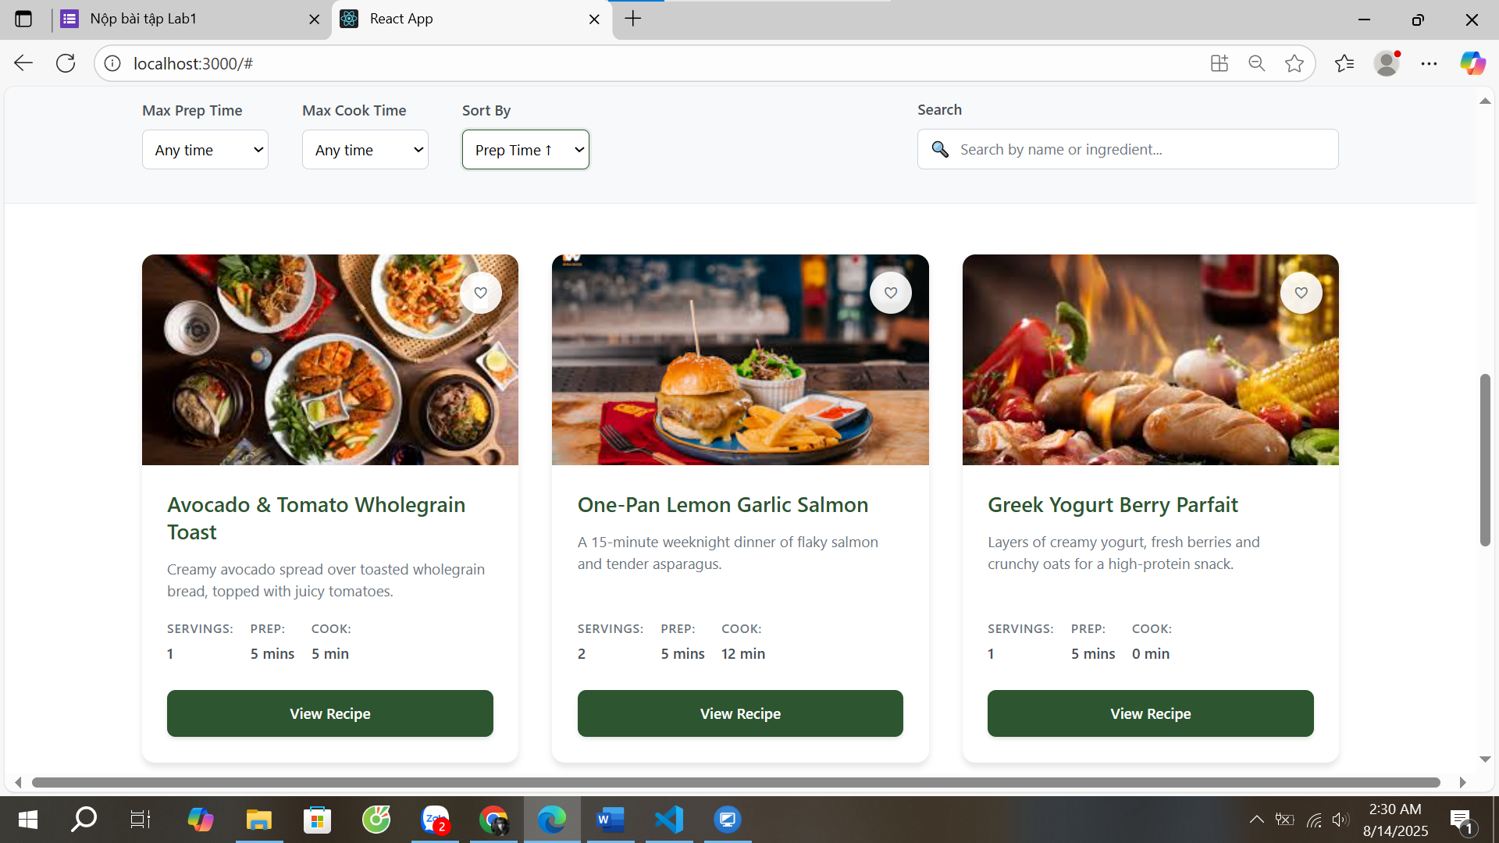

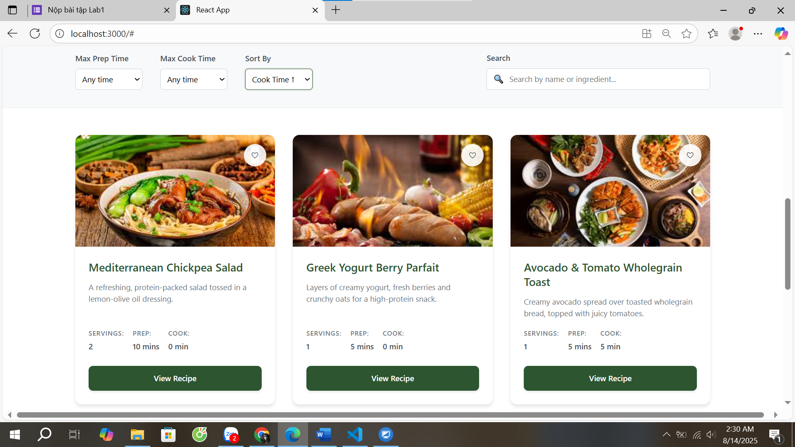

import React, { useEffect, useState } from 'react';

import './Filters.css';

const Filters = ({ onFilterChange, onSearchChange, onSortChange }) => {

  const [maxPrepTime, setMaxPrepTime] = useState('');

  const [maxCookTime, setMaxCookTime] = useState('');

  const [searchTerm, setSearchTerm] = useState('');

  const [debouncedSearchTerm, setDebouncedSearchTerm] = useState('');

  const [sortBy, setSortBy] = useState('');

  // Debounce search term

  useEffect(() => {

    const timer = setTimeout(() => {

      setDebouncedSearchTerm(searchTerm);

    }, 300);

    return () => clearTimeout(timer);

  }, [searchTerm]);

  // Notify parent component when filters change

  useEffect(() => {

    onFilterChange({ maxPrepTime, maxCookTime });

  }, [maxPrepTime, maxCookTime, onFilterChange]);

  // Notify parent component when search term changes

  useEffect(() => {

    onSearchChange(debouncedSearchTerm);

  }, [debouncedSearchTerm, onSearchChange]);

  // Notify parent component when sort changes

  useEffect(() => {

    onSortChange(sortBy);

  }, [sortBy, onSortChange]);

  const handleSearchChange = (e) => {

    setSearchTerm(e.target.value);

  };

  return (

    <section className="filters">

      <div className="filters-container">

        <div className="filters-left">

          <div className="filter-group">

            <label htmlFor="maxPrepTime" className="filter-label">Max Prep Time</label>

            <select

              id="maxPrepTime"

              value={maxPrepTime}

              onChange={(e) => setMaxPrepTime(e.target.value)}

              className="filter-select"

            >

              <option value="">Any time</option>

              <option value="5">5 minutes</option>

              <option value="10">10 minutes</option>

              <option value="15">15 minutes</option>

              <option value="20">20 minutes</option>

            </select>

          </div>

          <div className="filter-group">

            <label htmlFor="maxCookTime" className="filter-label">Max Cook Time</label>

            <select

              id="maxCookTime"

              value={maxCookTime}

              onChange={(e) => setMaxCookTime(e.target.value)}

              className="filter-select"

            >

              <option value="">Any time</option>

              <option value="5">5 minutes</option>

              <option value="10">10 minutes</option>

              <option value="15">15 minutes</option>

              <option value="20">20 minutes</option>

            </select>

          </div>

          <div className="filter-group">

            <label htmlFor="sortBy" className="filter-label">Sort By</label>

            <select

              id="sortBy"

              value={sortBy}

              onChange={(e) => setSortBy(e.target.value)}

              className="filter-select"

            >

              <option value="">Default order</option>

              <option value="name-asc">Name A → Z</option>

              <option value="name-desc">Name Z → A</option>

              <option value="prep-asc">Prep Time ↑</option>

              <option value="prep-desc">Prep Time ↓</option>

              <option value="cook-asc">Cook Time ↑</option>

              <option value="cook-desc">Cook Time ↓</option>

            </select>

          </div>

        </div>

        <div className="filters-right">

          <div className="search-group">

            <label htmlFor="search" className="search-label">Search</label>

            <div className="search-input-container">

              <span className="search-icon">🔍</span>

              <input

                type="text"

                id="search"

                placeholder="Search by name or ingredient..."

                value={searchTerm}

                onChange={handleSearchChange}

                className="search-input"

              />

            </div>

          </div>

        </div>

      </div>

    </section>

  );

};

export default Filters;

1. Tính năng Add to Favourite + Badge

* Trên mỗi **RecipeCard** có nút ♡, text kèm icon: **Add to Favourite**.
* Dùng **Toast** báo “Added to favourites” (tự ẩn trong 5s)

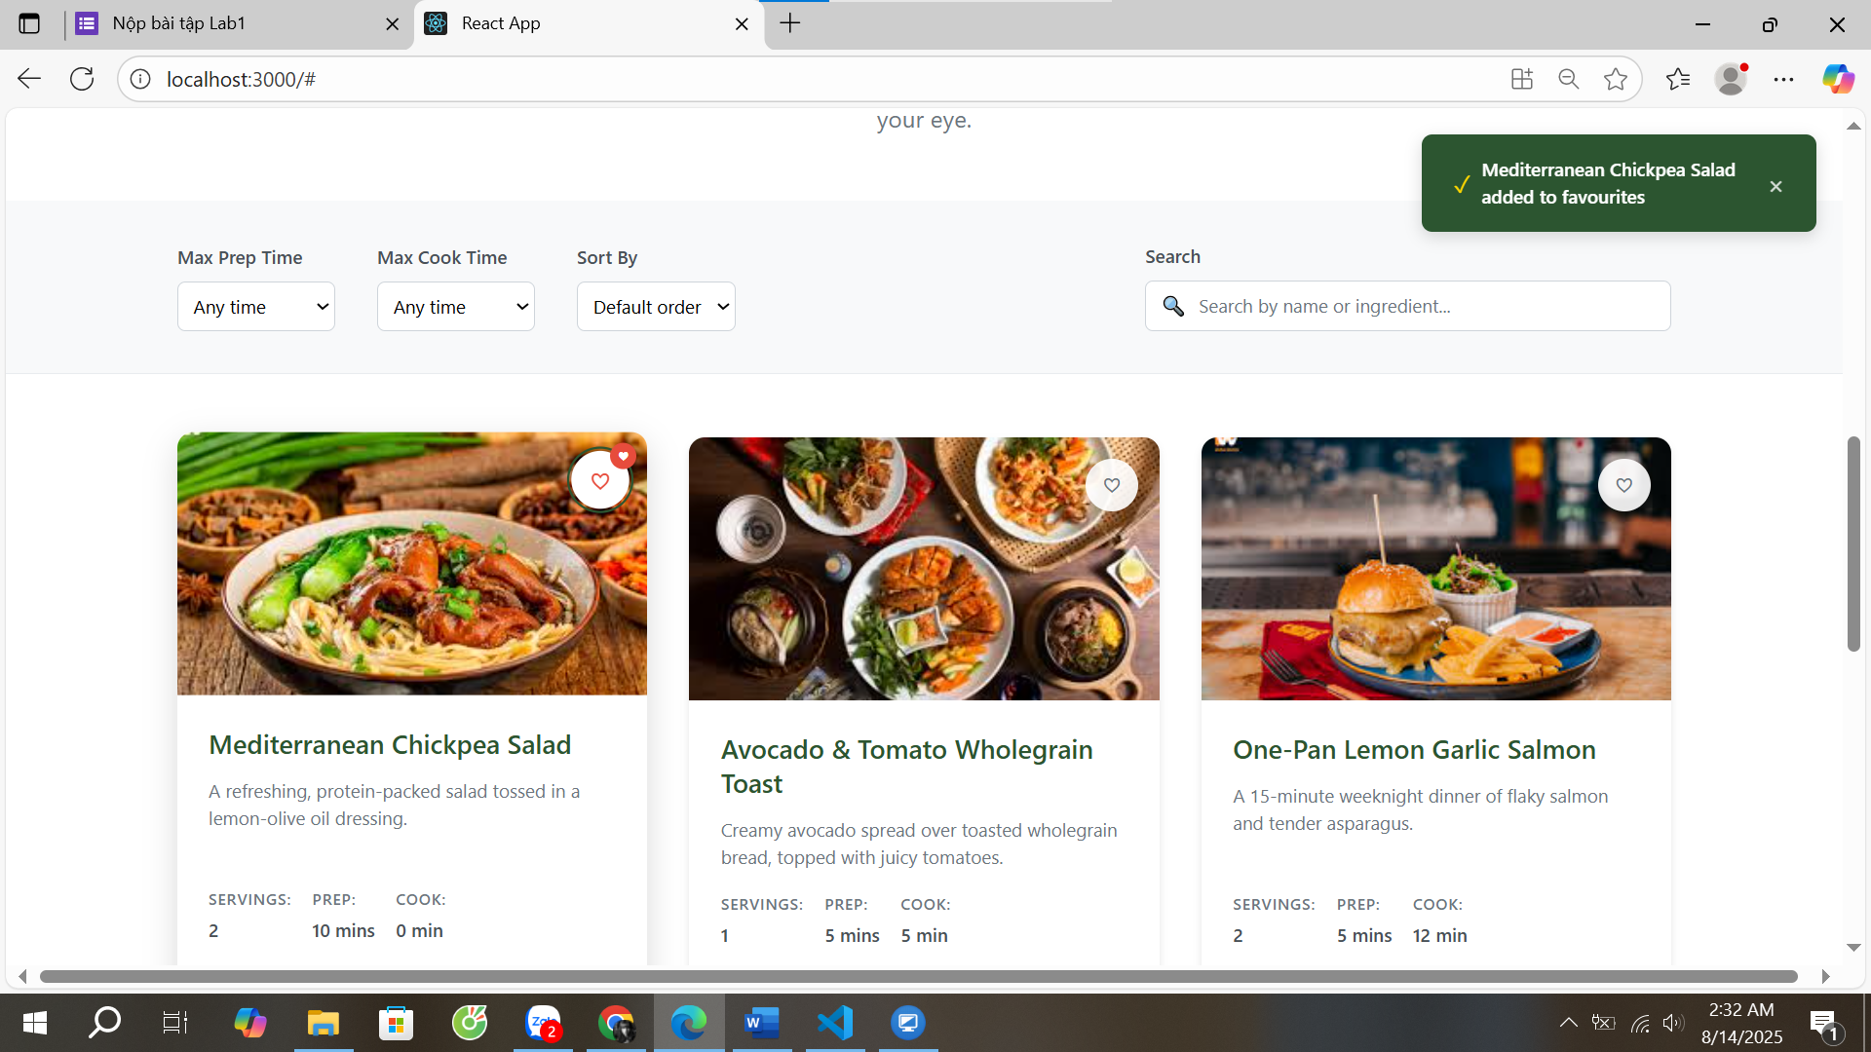

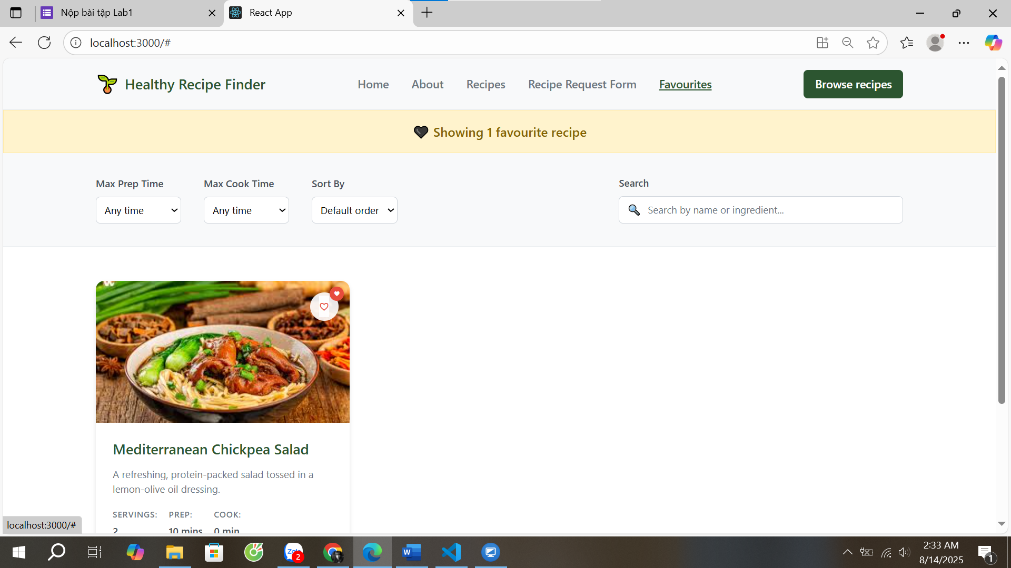

import React from 'react';

const Pagination = ({

  currentPage,

  totalPages,

  totalItems,

  onPageChange

}) => {

  // Generate page numbers to display

  const getPageNumbers = () => {

    const pages = [];

    const maxVisiblePages = 5;

    if (totalPages <= maxVisiblePages) {

      // Show all pages if total is small

      for (let i = 1; i <= totalPages; i++) {

        pages.push(i);

      }

    } else {

      // Show pages around current page

      let start = Math.max(1, currentPage - Math.floor(maxVisiblePages / 2));

      let end = Math.min(totalPages, start + maxVisiblePages - 1);

      if (end - start + 1 < maxVisiblePages) {

        start = Math.max(1, end - maxVisiblePages + 1);

      }

      for (let i = start; i <= end; i++) {

        pages.push(i);

      }

    }

    return pages;

  };

  const pageNumbers = getPageNumbers();

  return (

    <div style={styles.paginationContainer}>

      {/* Pagination controls */}

      <div style={styles.paginationControls}>

        {/* First button */}

        <button

          style={currentPage === 1 ? styles.navigationButtonDisabled : styles.navigationButton}

          onClick={() => onPageChange(1)}

          disabled={currentPage === 1}

          onMouseEnter={(e) => {

            if (currentPage !== 1) {

              e.target.style.backgroundColor = '#f8f9fa';

              e.target.style.borderColor = '#2c5530';

            }

          }}

          onMouseLeave={(e) => {

            if (currentPage !== 1) {

              e.target.style.backgroundColor = 'white';

              e.target.style.borderColor = '#ced4da';

            }

          }}

        >

          &lt;&lt;

        </button>

        {/* Previous button */}

        <button

          style={currentPage === 1 ? styles.navigationButtonDisabled : styles.navigationButton}

          onClick={() => onPageChange(currentPage - 1)}

          disabled={currentPage === 1}

          onMouseEnter={(e) => {

            if (currentPage !== 1) {

              e.target.style.backgroundColor = '#f8f9fa';

              e.target.style.borderColor = '#2c5530';

            }

          }}

          onMouseLeave={(e) => {

            if (currentPage !== 1) {

              e.target.style.backgroundColor = 'white';

              e.target.style.borderColor = '#ced4da';

            }

          }}

        >

          &lt;

        </button>

        {/* Page numbers */}

        {pageNumbers.map(pageNum => (

          <button

            key={pageNum}

            style={pageNum === currentPage ? styles.pageButtonActive : styles.pageButton}

            onClick={() => onPageChange(pageNum)}

            onMouseEnter={(e) => {

              if (pageNum !== currentPage) {

                e.target.style.backgroundColor = '#f8f9fa';

                e.target.style.borderColor = '#2c5530';

              }

            }}

            onMouseLeave={(e) => {

              if (pageNum !== currentPage) {

                e.target.style.backgroundColor = 'white';

                e.target.style.borderColor = '#ced4da';

              }

            }}

          >

            {pageNum}

          </button>

        ))}

        {/* Next button */}

        <button

          style={currentPage === totalPages ? styles.navigationButtonDisabled : styles.navigationButton}

          onClick={() => onPageChange(currentPage + 1)}

          disabled={currentPage === totalPages}

          onMouseEnter={(e) => {

            if (currentPage !== totalPages) {

              e.target.style.backgroundColor = '#f8f9fa';

              e.target.style.borderColor = '#2c5530';

            }

          }}

          onMouseLeave={(e) => {

            if (currentPage !== totalPages) {

              e.target.style.backgroundColor = 'white';

              e.target.style.borderColor = '#ced4da';

            }

          }}

        >

          &gt;

        </button>

        {/* Last button */}

        <button

          style={currentPage === totalPages ? styles.navigationButtonDisabled : styles.navigationButton}

          onClick={() => onPageChange(totalPages)}

          disabled={currentPage === totalPages}

          onMouseEnter={(e) => {

            if (currentPage !== totalPages) {

              e.target.style.backgroundColor = '#f8f9fa';

              e.target.style.borderColor = '#2c5530';

            }

          }}

          onMouseLeave={(e) => {

            if (currentPage !== totalPages) {

              e.target.style.backgroundColor = 'white';

              e.target.style.borderColor = '#ced4da';

            }

          }}

        >

          &gt;&gt;

        </button>

      </div>

      {/* Page info */}

      <div style={styles.pageInfo}>

        Page {currentPage} of {totalPages} ({totalItems} total items)

      </div>

    </div>

  );

};

export default Pagination;

1. Thao tác với Forms

* Dòng chữ “Recipe Request Form” đặt ở trên phần Navbars, bên cạnh Recipes
* Khi click vào link này, sẽ hiển thị một form cho phép các thông tin sau:
  + Your Name (input text, placeholder="Enter your name").
  + Email Address (input email, placeholder="Enter your email").
  + Desired Ingredient (input text, placeholder="tự cho chi tiết cụ thể….").
  + Max Prep Time (select/dropdown: 5, 10, 15, 30 phút).
  + Notes (textarea, 3–5 dòng).
  + Nút **Submit Request** màu **primary**.
  + Icon (ví dụ send hoặc paper-plane) dùng react-icons (tùy chọn).
* Feedback cơ bản:
  + Thêm Form.Control.Feedback dưới mỗi trường với nội dung ví dụ: “Please enter your name”, “Please provide a valid email”.
  + Chỉ cần viết sẵn feedback, chưa cần xử lý validate logic.

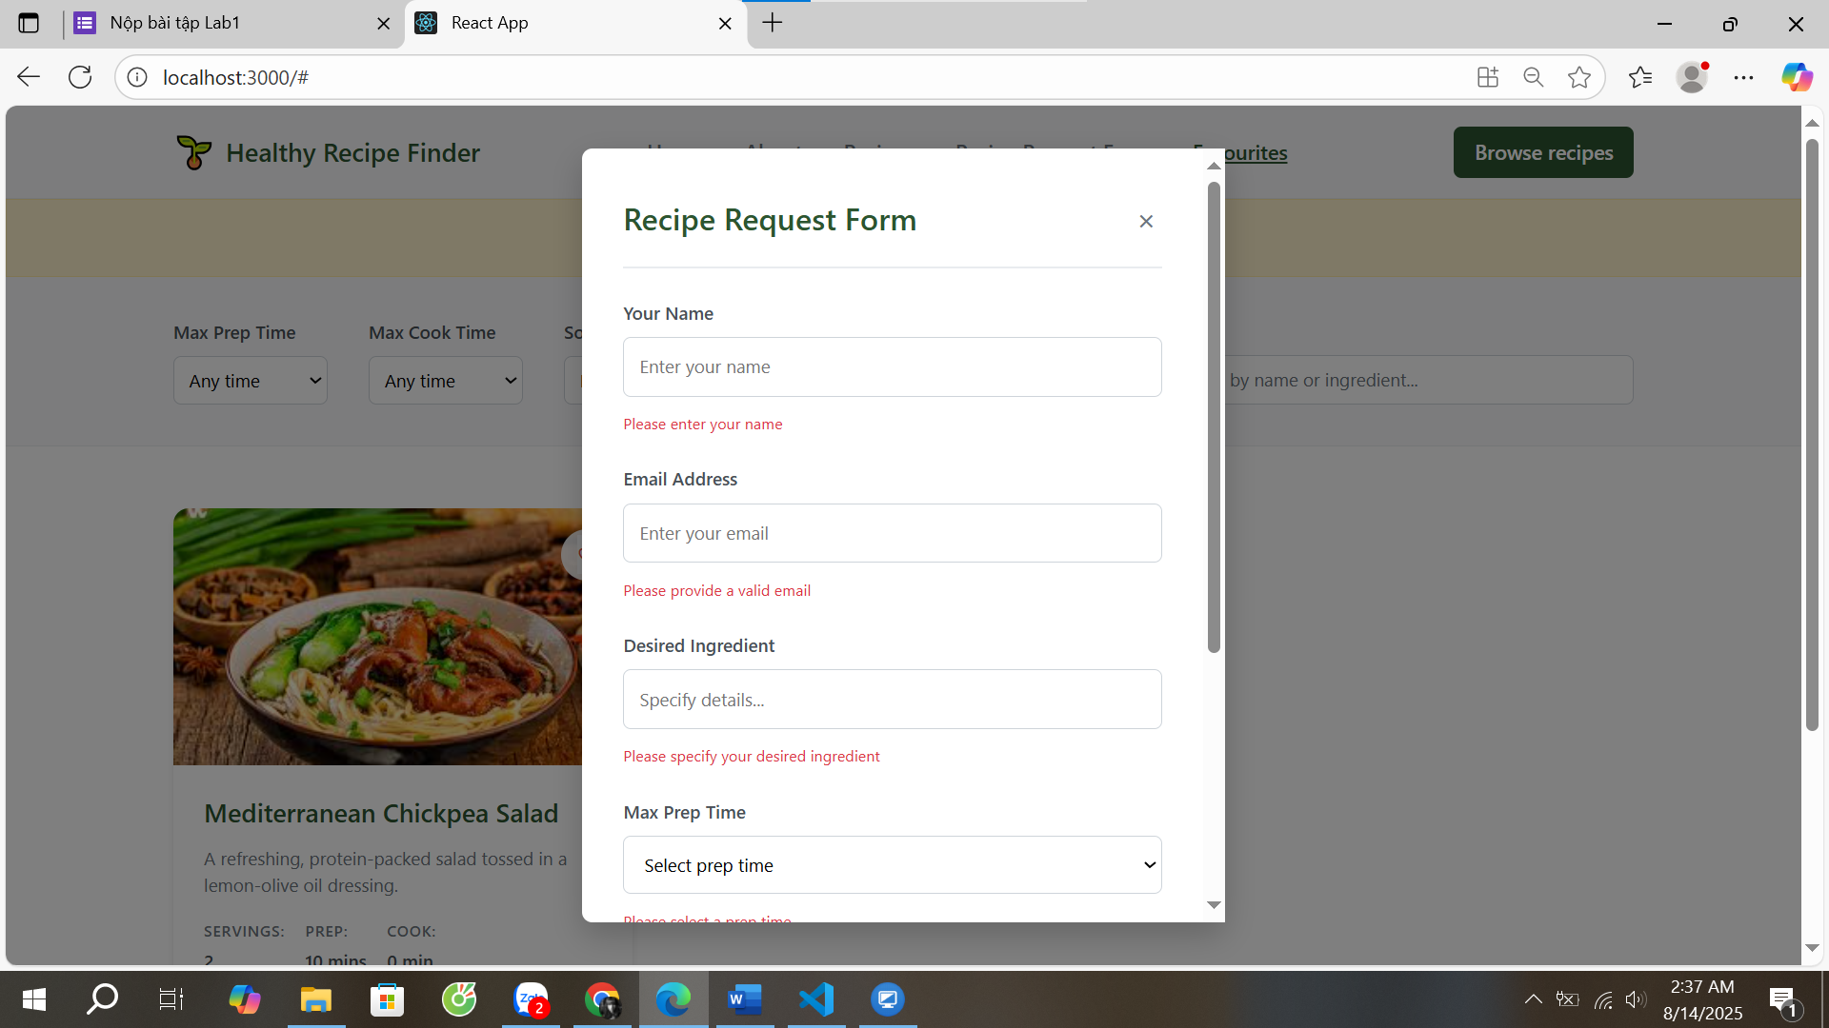

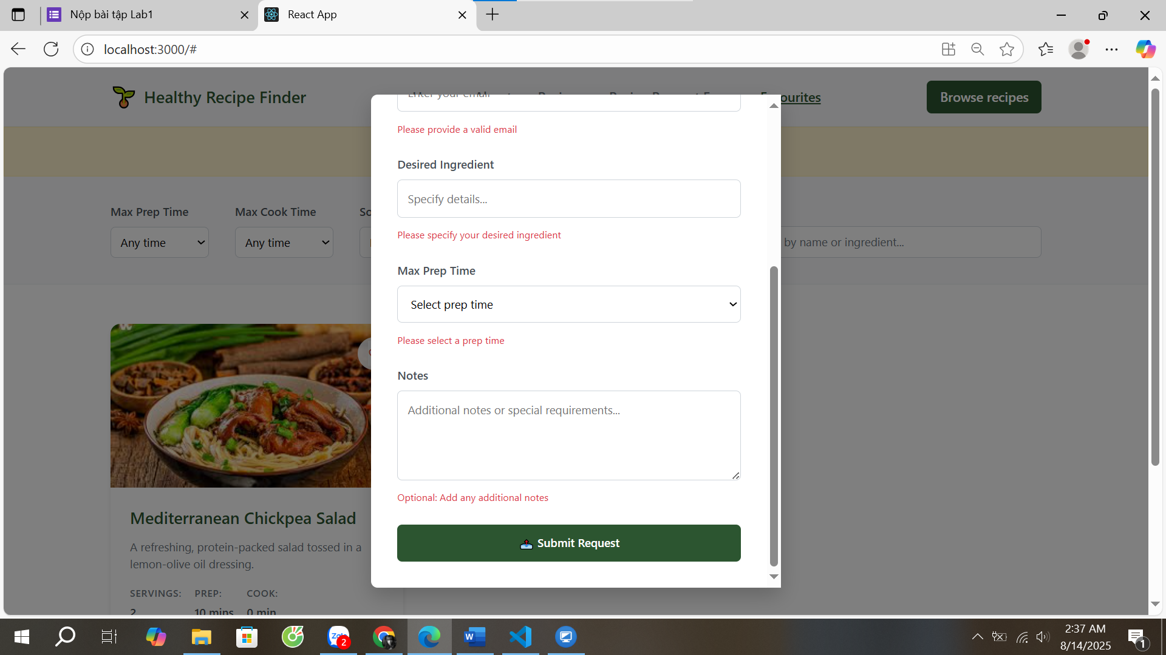

import React, { useState } from 'react';

const RecipeRequestForm = ({ onClose }) => {

  const [formData, setFormData] = useState({

    name: '',

    email: '',

    desiredIngredient: '',

    maxPrepTime: '',

    notes: ''

  });

  const handleInputChange = (e) => {

    const { name, value } = e.target;

    setFormData(prev => ({

      ...prev,

      [name]: value

    }));

  };

  const handleSubmit = (e) => {

    e.preventDefault();

    // TODO: Implement form submission logic

    console.log('Form submitted:', formData);

    alert('Recipe request submitted successfully!');

    onClose();

  };

  const styles = {

    overlay: {

      position: 'fixed',

      top: 0,

      left: 0,

      right: 0,

      bottom: 0,

      backgroundColor: 'rgba(0, 0, 0, 0.5)',

      display: 'flex',

      justifyContent: 'center',

      alignItems: 'center',

      zIndex: 1000

    },

    modal: {

      backgroundColor: 'white',

      borderRadius: '0.5rem',

      padding: '2rem',

      maxWidth: '500px',

      width: '90%',

      maxHeight: '90vh',

      overflowY: 'auto',

      boxShadow: '0 10px 25px rgba(0, 0, 0, 0.2)'

    },

    header: {

      display: 'flex',

      justifyContent: 'space-between',

      alignItems: 'center',

      marginBottom: '1.5rem',

      paddingBottom: '1rem',

      borderBottom: '2px solid #e9ecef'

    },

    title: {

      fontSize: '1.5rem',

      fontWeight: '600',

      color: '#2c5530',

      margin: 0

    },

    closeBtn: {

      background: 'none',

      border: 'none',

      fontSize: '1.5rem',

      cursor: 'pointer',

      color: '#6c757d',

      padding: '0.25rem',

      borderRadius: '0.25rem',

      transition: 'all 0.2s ease'

    },

    form: {

      display: 'flex',

      flexDirection: 'column',

      gap: '1.5rem'

    },

    formGroup: {

      display: 'flex',

      flexDirection: 'column',

      gap: '0.5rem'

    },

    label: {

      fontWeight: '600',

      color: '#495057',

      fontSize: '0.875rem'

    },

    input: {

      padding: '0.75rem',

      border: '1px solid #ced4da',

      borderRadius: '0.375rem',

      fontSize: '0.875rem',

      transition: 'border-color 0.2s ease'

    },

    select: {

      padding: '0.75rem',

      border: '1px solid #ced4da',

      borderRadius: '0.375rem',

      fontSize: '0.875rem',

      backgroundColor: 'white',

      transition: 'border-color 0.2s ease'

    },

    textarea: {

      padding: '0.75rem',

      border: '1px solid #ced4da',

      borderRadius: '0.375rem',

      fontSize: '0.875rem',

      resize: 'vertical',

      minHeight: '100px',

      fontFamily: 'inherit',

      transition: 'border-color 0.2s ease'

    },

    submitBtn: {

      backgroundColor: '#2c5530',

      color: 'white',

      border: 'none',

      padding: '0.75rem 1.5rem',

      borderRadius: '0.375rem',

      fontSize: '0.875rem',

      fontWeight: '600',

      cursor: 'pointer',

      transition: 'all 0.2s ease',

      display: 'flex',

      alignItems: 'center',

      justifyContent: 'center',

      gap: '0.5rem'

    },

    feedback: {

      fontSize: '0.75rem',

      color: '#dc3545',

      marginTop: '0.25rem'

    }

  };

  return (

    <div style={styles.overlay} onClick={onClose}>

      <div style={styles.modal} onClick={(e) => e.stopPropagation()}>

        <div style={styles.header}>

          <h2 style={styles.title}>Recipe Request Form</h2>

          <button

            style={styles.closeBtn}

            onClick={onClose}

            onMouseEnter={(e) => e.target.style.backgroundColor = '#f8f9fa'}

            onMouseLeave={(e) => e.target.style.backgroundColor = 'transparent'}

          >

            ×

          </button>

        </div>

        <form style={styles.form} onSubmit={handleSubmit}>

          <div style={styles.formGroup}>

            <label style={styles.label} htmlFor="name">Your Name</label>

            <input

              type="text"

              id="name"

              name="name"

              placeholder="Enter your name"

              value={formData.name}

              onChange={handleInputChange}

              style={styles.input}

              required

            />

            <div style={styles.feedback}>Please enter your name</div>

          </div>

          <div style={styles.formGroup}>

            <label style={styles.label} htmlFor="email">Email Address</label>

            <input

              type="email"

              id="email"

              name="email"

              placeholder="Enter your email"

              value={formData.email}

              onChange={handleInputChange}

              style={styles.input}

              required

            />

            <div style={styles.feedback}>Please provide a valid email</div>

          </div>

          <div style={styles.formGroup}>

            <label style={styles.label} htmlFor="desiredIngredient">Desired Ingredient</label>

            <input

              type="text"

              id="desiredIngredient"

              name="desiredIngredient"

              placeholder="Specify details..."

              value={formData.desiredIngredient}

              onChange={handleInputChange}

              style={styles.input}

              required

            />

            <div style={styles.feedback}>Please specify your desired ingredient</div>

          </div>

          <div style={styles.formGroup}>

            <label style={styles.label} htmlFor="maxPrepTime">Max Prep Time</label>

            <select

              id="maxPrepTime"

              name="maxPrepTime"

              value={formData.maxPrepTime}

              onChange={handleInputChange}

              style={styles.select}

              required

            >

              <option value="">Select prep time</option>

              <option value="5">5 minutes</option>

              <option value="10">10 minutes</option>

              <option value="15">15 minutes</option>

              <option value="30">30 minutes</option>

            </select>

            <div style={styles.feedback}>Please select a prep time</div>

          </div>

          <div style={styles.formGroup}>

            <label style={styles.label} htmlFor="notes">Notes</label>

            <textarea

              id="notes"

              name="notes"

              placeholder="Additional notes or special requirements..."

              value={formData.notes}

              onChange={handleInputChange}

              style={styles.textarea}

              rows="4"

            />

            <div style={styles.feedback}>Optional: Add any additional notes</div>

          </div>

          <button

            type="submit"

            style={styles.submitBtn}

            onMouseEnter={(e) => e.target.style.backgroundColor = '#1e3a22'}

            onMouseLeave={(e) => e.target.style.backgroundColor = '#2c5530'}

          >

            📤 Submit Request

          </button>

        </form>

      </div>

    </div>

  );

};

export default RecipeRequestForm;

1. Dùng phân trang Pagination của React

* Mặc định **6 RecipeCard** trên mỗi trang
* Có Dropdown “Items per page” để chọn: **6, 9, 12**.
  + First (<<), Previous (<), Next (>), Last (>>)
  + Số trang (1, 2, 3, …)
  + Nút của trang hiện tại phải active.
  + Nút First/Previous disable khi đang ở trang 1; Next/Last disable khi ở trang cuối.

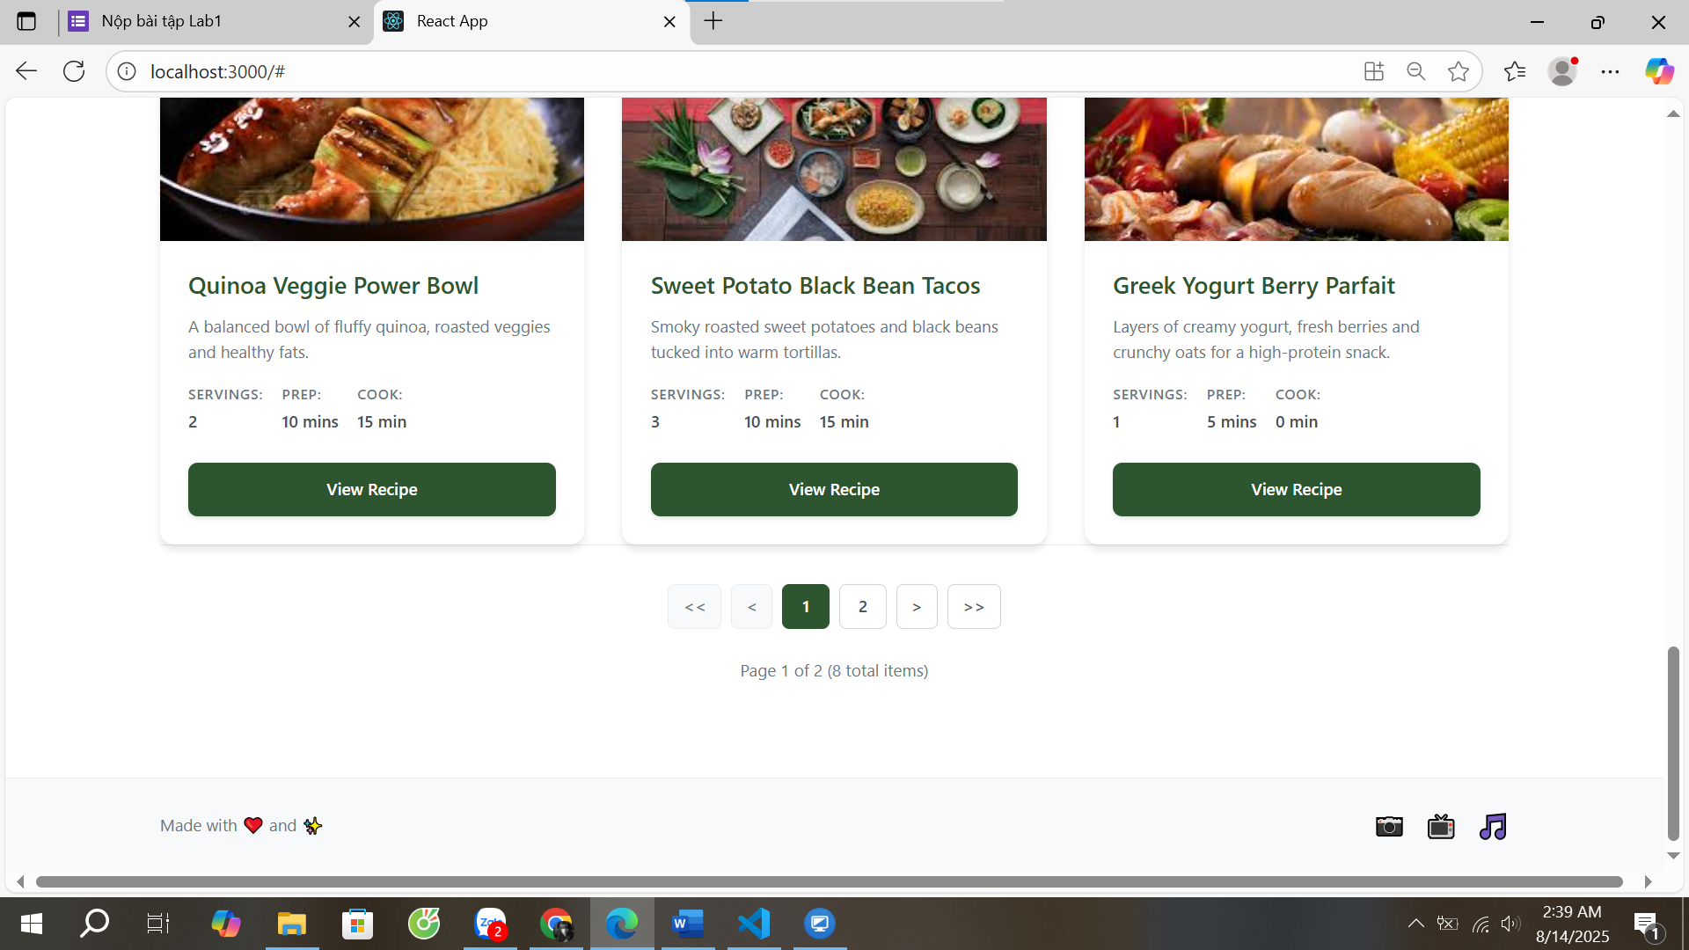

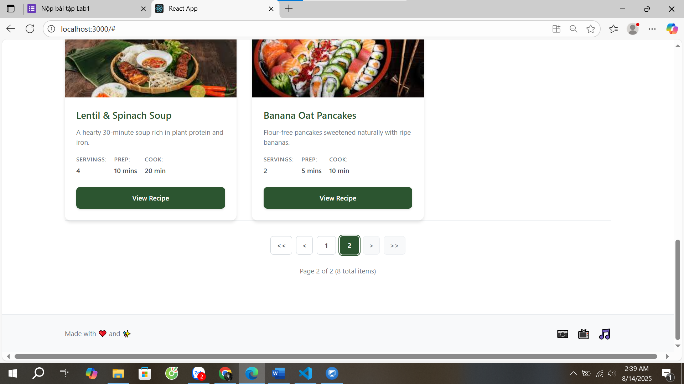

import React from 'react';

const Pagination = ({

  currentPage,

  totalPages,

  totalItems,

  onPageChange

}) => {

  const styles = {

    paginationContainer: {

      display: 'flex',

      flexDirection: 'column',

      alignItems: 'center',

      gap: '1rem',

      padding: '2rem 0',

      backgroundColor: '#ffffff',

      borderTop: '1px solid #e9ecef'

    },

    paginationControls: {

      display: 'flex',

      alignItems: 'center',

      gap: '0.5rem',

      flexWrap: 'wrap',

      justifyContent: 'center'

    },

    pageButton: {

      padding: '0.5rem 0.75rem',

      border: '1px solid #ced4da',

      backgroundColor: 'white',

      color: '#495057',

      borderRadius: '0.375rem',

      cursor: 'pointer',

      fontSize: '0.875rem',

      fontWeight: '500',

      transition: 'all 0.2s ease',

      minWidth: '40px',

      textAlign: 'center'

    },

    pageButtonActive: {

      padding: '0.5rem 0.75rem',

      border: '1px solid #2c5530',

      backgroundColor: '#2c5530',

      color: 'white',

      borderRadius: '0.375rem',

      cursor: 'pointer',

      fontSize: '0.875rem',

      fontWeight: '500',

      transition: 'all 0.2s ease',

      minWidth: '40px',

      textAlign: 'center'

    },

    pageButtonDisabled: {

      padding: '0.5rem 0.75rem',

      border: '1px solid #e9ecef',

      backgroundColor: '#f8f9fa',

      color: '#6c757d',

      borderRadius: '0.375rem',

      cursor: 'not-allowed',

      fontSize: '0.875rem',

      fontWeight: '500',

      minWidth: '40px',

      textAlign: 'center'

    },

    navigationButton: {

      padding: '0.5rem 0.75rem',

      border: '1px solid #ced4da',

      backgroundColor: 'white',

      color: '#495057',

      borderRadius: '0.375rem',

      cursor: 'pointer',

      fontSize: '0.875rem',

      fontWeight: '500',

      transition: 'all 0.2s ease'

    },

    navigationButtonDisabled: {

      padding: '0.5rem 0.75rem',

      border: '1px solid #e9ecef',

      backgroundColor: '#f8f9fa',

      color: '#6c757d',

      borderRadius: '0.375rem',

      cursor: 'not-allowed',

      fontSize: '0.875rem',

      fontWeight: '500'

    },

    pageInfo: {

      fontSize: '0.875rem',

      color: '#6c757d',

      marginTop: '0.5rem'

    }

  };

  // Generate page numbers to display

  const getPageNumbers = () => {

    const pages = [];

    const maxVisiblePages = 5;

    if (totalPages <= maxVisiblePages) {

      // Show all pages if total is small

      for (let i = 1; i <= totalPages; i++) {

        pages.push(i);

      }

    } else {

      // Show pages around current page

      let start = Math.max(1, currentPage - Math.floor(maxVisiblePages / 2));

      let end = Math.min(totalPages, start + maxVisiblePages - 1);

      if (end - start + 1 < maxVisiblePages) {

        start = Math.max(1, end - maxVisiblePages + 1);

      }

      for (let i = start; i <= end; i++) {

        pages.push(i);

      }

    }

    return pages;

  };

  const pageNumbers = getPageNumbers();

  return (

    <div style={styles.paginationContainer}>

      {/* Pagination controls */}

      <div style={styles.paginationControls}>

        {/* First button */}

        <button

          style={currentPage === 1 ? styles.navigationButtonDisabled : styles.navigationButton}

          onClick={() => onPageChange(1)}

          disabled={currentPage === 1}

          onMouseEnter={(e) => {

            if (currentPage !== 1) {

              e.target.style.backgroundColor = '#f8f9fa';

              e.target.style.borderColor = '#2c5530';

            }

          }}

          onMouseLeave={(e) => {

            if (currentPage !== 1) {

              e.target.style.backgroundColor = 'white';

              e.target.style.borderColor = '#ced4da';

            }

          }}

        >

          &lt;&lt;

        </button>

        {/* Previous button */}

        <button

          style={currentPage === 1 ? styles.navigationButtonDisabled : styles.navigationButton}

          onClick={() => onPageChange(currentPage - 1)}

          disabled={currentPage === 1}

          onMouseEnter={(e) => {

            if (currentPage !== 1) {

              e.target.style.backgroundColor = '#f8f9fa';

              e.target.style.borderColor = '#2c5530';

            }

          }}

          onMouseLeave={(e) => {

            if (currentPage !== 1) {

              e.target.style.backgroundColor = 'white';

              e.target.style.borderColor = '#ced4da';

            }

          }}

        >

          &lt;

        </button>

        {/* Page numbers */}

        {pageNumbers.map(pageNum => (

          <button

            key={pageNum}

            style={pageNum === currentPage ? styles.pageButtonActive : styles.pageButton}

            onClick={() => onPageChange(pageNum)}

            onMouseEnter={(e) => {

              if (pageNum !== currentPage) {

                e.target.style.backgroundColor = '#f8f9fa';

                e.target.style.borderColor = '#2c5530';

              }

            }}

            onMouseLeave={(e) => {

              if (pageNum !== currentPage) {

                e.target.style.backgroundColor = 'white';

                e.target.style.borderColor = '#ced4da';

              }

            }}

          >

            {pageNum}

          </button>

        ))}

        {/* Next button */}

        <button

          style={currentPage === totalPages ? styles.navigationButtonDisabled : styles.navigationButton}

          onClick={() => onPageChange(currentPage + 1)}

          disabled={currentPage === totalPages}

          onMouseEnter={(e) => {

            if (currentPage !== totalPages) {

              e.target.style.backgroundColor = '#f8f9fa';

              e.target.style.borderColor = '#2c5530';

            }

          }}

          onMouseLeave={(e) => {

            if (currentPage !== totalPages) {

              e.target.style.backgroundColor = 'white';

              e.target.style.borderColor = '#ced4da';

            }

          }}

        >

          &gt;

        </button>

        {/* Last button */}

        <button

          style={currentPage === totalPages ? styles.navigationButtonDisabled : styles.navigationButton}

          onClick={() => onPageChange(totalPages)}

          disabled={currentPage === totalPages}

          onMouseEnter={(e) => {

            if (currentPage !== totalPages) {

              e.target.style.backgroundColor = '#f8f9fa';

              e.target.style.borderColor = '#2c5530';

            }

          }}

          onMouseLeave={(e) => {

            if (currentPage !== totalPages) {

              e.target.style.backgroundColor = 'white';

              e.target.style.borderColor = '#ced4da';

            }

          }}

        >

          &gt;&gt;

        </button>

      </div>

      {/* Page info */}

      <div style={styles.pageInfo}>

        Page {currentPage} of {totalPages} ({totalItems} total items)

      </div>

    </div>

  );

};

export default Pagination;

APP.JS

import React, { useCallback, useState } from 'react';

import './App.css';

import CarouselComponent from './components/Carousel';

import Footer from './components/Footer';

import Hero from './components/Hero';

import Navbar from './components/Navbar';

import RecipeGrid from './components/RecipeGrid';

import RecipeModal from './components/RecipeModal';

import RecipeRequestForm from './components/RecipeRequestForm';

import Toast from './components/Toast';

import Filters from './Filters';

import { recipes } from './recipes';

function App() {

  const [filteredRecipes, setFilteredRecipes] = useState(recipes);

  const [selectedRecipe, setSelectedRecipe] = useState(null);

  const [isModalOpen, setIsModalOpen] = useState(false);

  const [filters, setFilters] = useState({ maxPrepTime: '', maxCookTime: '' });

  const [searchTerm, setSearchTerm] = useState('');

  const [sortBy, setSortBy] = useState('');

  const [favourites, setFavourites] = useState(new Set());

  const [showToast, setShowToast] = useState(false);

  const [toastMessage, setToastMessage] = useState('');

  const [currentView, setCurrentView] = useState('home');

  const [showRecipeRequestForm, setShowRecipeRequestForm] = useState(false);

  const [currentPage, setCurrentPage] = useState(1);

  const [itemsPerPage, setItemsPerPage] = useState(6);

  // Filter, search and sort recipes

  const filterRecipes = useCallback((newFilters, newSearchTerm, newSortBy) => {

    let filtered = recipes;

    // Apply favourites filter first

    if (currentView === 'favourites') {

      filtered = filtered.filter((recipe, index) => favourites.has(index));

    }

    // Apply search filter

    if (newSearchTerm) {

      const searchLower = newSearchTerm.toLowerCase();

      filtered = filtered.filter(recipe =>

        recipe.title.toLowerCase().includes(searchLower) ||

        recipe.description.toLowerCase().includes(searchLower)

      );

    }

    // Apply prep time filter

    if (newFilters.maxPrepTime) {

      filtered = filtered.filter(recipe => recipe.prep <= parseInt(newFilters.maxPrepTime));

    }

    // Apply cook time filter

    if (newFilters.maxCookTime) {

      filtered = filtered.filter(recipe => recipe.cook <= parseInt(newFilters.maxCookTime));

    }

    // Apply sorting

    if (newSortBy) {

      filtered = [...filtered].sort((a, b) => {

        switch (newSortBy) {

          case 'name-asc':

            return a.title.localeCompare(b.title);

          case 'name-desc':

            return b.title.localeCompare(a.title);

          case 'prep-asc':

            return a.prep - b.prep;

          case 'prep-desc':

            return b.prep - a.prep;

          case 'cook-asc':

            return a.cook - b.cook;

          case 'cook-desc':

            return b.cook - a.cook;

          default:

            return 0;

        }

      });

    }

    setFilteredRecipes(filtered);

    setCurrentPage(1); // Reset to first page when filtering

  }, [currentView, favourites]);

  // Handle filter changes

  const handleFilterChange = useCallback((newFilters) => {

    setFilters(newFilters);

    filterRecipes(newFilters, searchTerm, sortBy);

  }, [filterRecipes, searchTerm, sortBy]);

  // Handle search changes

  const handleSearchChange = useCallback((newSearchTerm) => {

    setSearchTerm(newSearchTerm);

    filterRecipes(filters, newSearchTerm, sortBy);

  }, [filterRecipes, filters, sortBy]);

  // Handle sort changes

  const handleSortChange = useCallback((newSortBy) => {

    setSortBy(newSortBy);

    filterRecipes(filters, searchTerm, newSortBy);

  }, [filterRecipes, filters, searchTerm]);

  // Handle view recipe

  const handleViewRecipe = useCallback((recipe) => {

    setSelectedRecipe(recipe);

    setIsModalOpen(true);

  }, []);

  // Handle close modal

  const handleCloseModal = useCallback(() => {

    setIsModalOpen(false);

    setSelectedRecipe(null);

  }, []);

  // Handle add to favourite

  const handleAddToFavourite = useCallback((recipe, index) => {

    const newFavourites = new Set(favourites);

    if (newFavourites.has(index)) {

      newFavourites.delete(index);

      setToastMessage(`${recipe.title} removed from favourites`);

    } else {

      newFavourites.add(index);

      setToastMessage(`${recipe.title} added to favourites`);

    }

    setFavourites(newFavourites);

    setShowToast(true);

  }, [favourites]);

  // Handle show home

  const handleShowHome = useCallback(() => {

    setCurrentView('home');

  }, []);

  // Handle show recipes

  const handleShowRecipes = useCallback(() => {

    setCurrentView('recipes');

  }, []);

  // Handle show favourites

  const handleShowFavourites = useCallback(() => {

    setCurrentView(currentView === 'favourites' ? 'home' : 'favourites');

  }, [currentView]);

  // Handle show recipe request form

  const handleShowRecipeRequest = useCallback(() => {

    setShowRecipeRequestForm(true);

  }, []);

  // Handle page change

  const handlePageChange = useCallback((newPage) => {

    setCurrentPage(newPage);

  }, []);

  // Handle items per page change

  const handleItemsPerPageChange = useCallback((newItemsPerPage) => {

    setItemsPerPage(newItemsPerPage);

    setCurrentPage(1); // Reset to first page when changing items per page

  }, []);

  // Handle add to cart

  const handleAddToCart = useCallback(() => {

    alert(`${selectedRecipe.title} has been added to cart!`);

    handleCloseModal();

  }, [selectedRecipe, handleCloseModal]);

  return (

    <div className="App">

      <Navbar

        favourites={favourites}

        onShowFavourites={handleShowFavourites}

        onShowHome={handleShowHome}

        onShowRecipes={handleShowRecipes}

        onShowRecipeRequest={handleShowRecipeRequest}

        currentView={currentView}

      />

      {currentView === 'home' && (

        <>

          <CarouselComponent />

          <Hero />

        </>

      )}

      {currentView === 'recipes' && (

        <div style={{

          backgroundColor: '#e8f5e8',

          border: '1px solid #c3e6c3',

          color: '#2c5530',

          padding: '1rem 2rem',

          textAlign: 'center',

          fontSize: '1.125rem',

          fontWeight: '500'

        }}>

          🍽️ Showing all recipes

        </div>

      )}

      {currentView === 'favourites' && (

        <div style={{

          backgroundColor: '#fff3cd',

          border: '1px solid #ffeaa7',

          color: '#856404',

          padding: '1rem 2rem',

          textAlign: 'center',

          fontSize: '1.125rem',

          fontWeight: '500'

        }}>

          🖤 Showing {favourites.size} favourite recipe{favourites.size !== 1 ? 's' : ''}

        </div>

      )}

      <Filters

        onFilterChange={handleFilterChange}

        onSearchChange={handleSearchChange}

        onSortChange={handleSortChange}

      />

      <RecipeGrid

        recipes={filteredRecipes}

        onViewRecipe={handleViewRecipe}

        onAddToFavourite={handleAddToFavourite}

        favourites={favourites}

        currentPage={currentPage}

        itemsPerPage={itemsPerPage}

        onPageChange={handlePageChange}

      />

      <Footer />

      <RecipeModal

        recipe={selectedRecipe}

        isOpen={isModalOpen}

        onClose={handleCloseModal}

        onAddToCart={handleAddToCart}

      />

      <Toast

        message={toastMessage}

        isVisible={showToast}

        onClose={() => setShowToast(false)}

        duration={5000}

      />

      {showRecipeRequestForm && (

        <RecipeRequestForm

          onClose={() => setShowRecipeRequestForm(false)}

        />

      )}

    </div>

  );

}

export default App;